Lab Exercise 5 – Python Script for Load Generate

This script will do the following:

- Writes 100,000 unique rows
- Uses a 50 KB random payload per row
- Generates approximately 4.77 GB of payload
- Uses 10 concurrent workers
- Uses batch writes
- Creates a deliberate hotspot around hotspot#... row keys
- Correctly handles your result.code being an integer
- Reports successful and failed writes
- Prints throughput
- Uses random data so compression doesn't make the payload artificially tiny

heavy_load.py
import os
import random
import time
from concurrent.futures import ThreadPoolExecutor, as_completed

from google.cloud import bigtable

# ============================================================
# CONFIGURATION
# ============================================================

PROJECT_ID = os.environ["GOOGLE_CLOUD_PROJECT"]
INSTANCE_ID = os.environ["INSTANCE_ID"]
TABLE_ID = os.environ["TABLE_ID"]

# Existing column family
COLUMN_FAMILY = "metrics"

# ------------------------------------------------------------
# Load configuration
# ------------------------------------------------------------

# Total number of unique rows
TOTAL_ROWS = 100000

# Payload size per row
# 50 KB
PAYLOAD_SIZE = 50 * 1024

# Rows written in one Bigtable batch
BATCH_SIZE = 100

# Number of concurrent workers
WORKERS = 10

# ============================================================
# BIGTABLE CONNECTION
# ============================================================

print("Connecting to Bigtable...")

client = bigtable.Client(
project=PROJECT_ID,
admin=True
)

instance = client.instance(INSTANCE_ID)

table = instance.table(TABLE_ID)

print("Connected.")
print()

# ============================================================
# GENERATE RANDOM PAYLOAD
# ============================================================
#
# IMPORTANT:
# Do NOT use:
#
# b"X" * PAYLOAD_SIZE
#
# because repetitive data compresses very well.
#
# os.urandom() generates random bytes and gives us a much
# more realistic payload.
# ============================================================

print("Generating random payload...")

payload = os.urandom(PAYLOAD_SIZE)

print(
f"Payload size: "
f"{len(payload) / 1024:.2f} KB"
)

print()

# ============================================================
# LOAD INFORMATION
# ============================================================

expected_gb = (
TOTAL_ROWS * PAYLOAD_SIZE
) / (1024 ** 3)

print("==========================================")
print(" BIGTABLE HEAVY LOAD TEST")
print("==========================================")
print(f"Project : {PROJECT_ID}")
print(f"Instance : {INSTANCE_ID}")
print(f"Table : {TABLE_ID}")
print(f"Rows : {TOTAL_ROWS:,}")
print(
f"Payload / row : "
f"{PAYLOAD_SIZE / 1024:.0f} KB"
)
print(
f"Expected payload: "
f"~{expected_gb:.2f} GB"
)
print(f"Batch size : {BATCH_SIZE}")
print(f"Workers : {WORKERS}")
print("Hotspot range : hotspot#001 - hotspot#100")
print("==========================================")
print()

# ============================================================
# WRITE ONE BATCH
# ============================================================

def write_batch(batch_number):

start = batch_number * BATCH_SIZE

end = min(
start + BATCH_SIZE,
TOTAL_ROWS
)

rows = []

for i in range(start, end):

# ----------------------------------------------------
# HOTSPOT
# ----------------------------------------------------
#
# Only 100 sensor IDs are used.
#
# Therefore traffic is concentrated into:
#
# hotspot#001
# hotspot#002
# ...
# hotspot#100
#
# But a timestamp + counter makes every row unique.
# ----------------------------------------------------

sensor_id = random.randint(1, 100)

timestamp = time.time_ns()

row_key = (
f"hotspot#"
f"{sensor_id:03d}"
f"#"
f"{timestamp}"
f"#"
f"{i}"
)

# Create Bigtable row
r = table.direct_row(row_key)

# ----------------------------------------------------
# SMALL COLUMN 1
# ----------------------------------------------------

r.set_cell(
COLUMN_FAMILY,
"temperature",
str(random.randint(20, 35))
)

# ----------------------------------------------------
# SMALL COLUMN 2
# ----------------------------------------------------

r.set_cell(
COLUMN_FAMILY,
"status",
"ONLINE"
)

# ----------------------------------------------------
# SMALL COLUMN 3
# ----------------------------------------------------

r.set_cell(
COLUMN_FAMILY,
"location",
"DEHRADUN"
)

# ----------------------------------------------------
# LARGE 50 KB COLUMN
# ----------------------------------------------------

r.set_cell(
COLUMN_FAMILY,
"payload",
payload
)

rows.append(r)

# --------------------------------------------------------
# BATCH WRITE
# --------------------------------------------------------

results = table.mutate_rows(rows)

# --------------------------------------------------------
# CHECK RESULTS
# --------------------------------------------------------

successful = 0
errors = 0

for result in results:

# In your installed Bigtable client,
# result.code is an integer.
#
# 0 = OK
#

if result.code == 0:
successful += 1
else:
errors += 1

return successful, errors

# ============================================================
# LOAD TEST
# ============================================================

total_batches = (
TOTAL_ROWS + BATCH_SIZE - 1
) // BATCH_SIZE

start_time = time.time()

successful_rows = 0
failed_rows = 0

completed_batches = 0

print("Starting load test...")
print()
print("Press CTRL+C to stop.")
print()

# ============================================================
# PARALLEL EXECUTION
# ============================================================

try:

with ThreadPoolExecutor(
max_workers=WORKERS
) as executor:

futures = []

for batch_number in range(total_batches):

future = executor.submit(
write_batch,
batch_number
)

futures.append(future)

# ----------------------------------------------------
# COLLECT RESULTS
# ----------------------------------------------------

for future in as_completed(futures):

successful, errors = future.result()

successful_rows += successful

failed_rows += errors

completed_batches += 1

# ------------------------------------------------
# DISPLAY PROGRESS
# ------------------------------------------------

if (
completed_batches % 10 == 0
or completed_batches == total_batches
):

elapsed = (
time.time() - start_time
)

if elapsed > 0:

rows_per_second = (
successful_rows /
elapsed
)

else:

rows_per_second = 0

data_gb = (
successful_rows *
PAYLOAD_SIZE
) / (1024 ** 3)

print(
f"Batches: "
f"{completed_batches:,}/"
f"{total_batches:,} | "
f"Rows: "
f"{successful_rows:,} | "
f"Errors: "
f"{failed_rows:,} | "
f"Data: "
f"{data_gb:.2f} GB | "
f"Rate: "
f"{rows_per_second:,.0f} rows/sec"
)

except KeyboardInterrupt:

print()
print("CTRL+C detected.")
print("Stopping load test...")

# ============================================================
# FINAL RESULTS
# ============================================================

elapsed = time.time() - start_time

if elapsed > 0:

rows_per_second = (
successful_rows /
elapsed
)

else:

rows_per_second = 0

actual_data_gb = (
successful_rows *
PAYLOAD_SIZE
) / (1024 ** 3)

print()
print()
print("==========================================")
print(" LOAD TEST COMPLETED")
print("==========================================")
print(
f"Successful rows : "
f"{successful_rows:,}"
)
print(
f"Failed rows : "
f"{failed_rows:,}"
)
print(
f"Payload / row : "
f"{PAYLOAD_SIZE / 1024:.0f} KB"
)
print(
f"Logical payload : "
f"~{actual_data_gb:.2f} GB"
)
print(
f"Elapsed time : "
f"{elapsed:.2f} seconds"
)
print(
f"Write rate : "
f"{rows_per_second:,.0f} rows/sec"
)
print("==========================================")

2. Set your environment variables
Since your table is called hotspot_test:
export PROJECT_ID=$(gcloud config get-value project)
export INSTANCE_ID="training-bigtable"
export TABLE_ID="hotspot_test"
export COLUMN_FAMILY="metrics"
For example, verify:
3. Make sure metrics exists
Run:
cbt ls hotspot_test
If metrics doesn't exist:
cbt createfamily hotspot_test metrics
Then:
cbt ls hotspot_test

4. Run the script
python3 heavy_load.py
You should see:
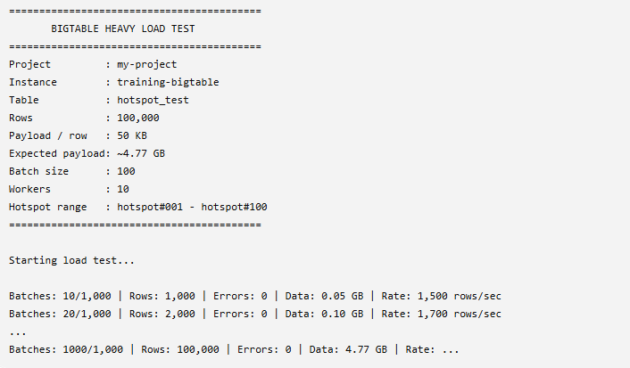
5. Check the table afterwards
In the Bigtable console, you should see substantially more storage than the 289.5 KB you showed earlier.
You can also check with:
cbt count hotspot_test
You should get approximately:
100000

